# 2.5 Parallel and Perpendicular Vectors, The Unit Vector

## PARALLEL AND ORTHOGONAL VECTORS

Two vectors $\vec{u}=\left\langle u_{x},\left.u_{y}\right\rangle \right.$ and $\vec{v}=\left\langle v_{x},\left.v_{y}\right\rangle \right.$ are **parallel** if the angle between them is 0° or 180°.

Also, two vectors $\vec{u}=\left\langle u_{x},\left.u_{y}\right\rangle \right.$ and $\vec{v}=\left\langle v_{x},\left.v_{y}\right\rangle \right.$ are parallel to each other if the vector $\vec{u}$ is some multiple of the vector $\vec{v}$.That is, they will be parallel if the vector $\vec{u}=c\vec{v}$, for some real number $c$. That is, $\vec{u}$ is some multiple of $\vec{v}$.

Two vectors $\vec{u}=\left\langle u_{x},\left.u_{y}\right\rangle \right.$ and $\vec{v}=\left\langle v_{x},\left.v_{y}\right\rangle \right.$ are **orthogonal** (perpendicular to each other) if the angle between them is 90° or 180°.

Use this shortcut: Two vectors are perpendicular to each other if their dot product is 0.

The two vectors $\vec{u}=\left.⟨2,-3\right\rangle$ and $\vec{v}=\left\langle -8,\left.12\right\rangle \right.$ are parallel to each other since the angle between them is $180°$.

Example (1)

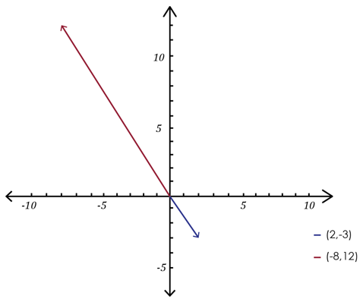

$$θ= \cos^{-1}\frac{\vec{u}∙\vec{v}}{‖\vec{u} ‖∙‖\vec{v} ‖}$$

$$θ= \cos^{-1}\frac{\left.⟨2,-3\right\rangle ∙\left\langle -8,\left.12\right\rangle \right.}{\sqrt{2^{2}+{\left(-3\right)}^{2}}∙\sqrt{{\left(-8\right)}^{2}+{12}^{2}}}$$

$$θ= \cos^{-1}\frac{2∙(-8)+\left(-3\right)∙12}{\sqrt{4+9}∙\sqrt{64+144}}$$

$$θ= \cos^{-1}\frac{-52}{\sqrt{13}∙\sqrt{208}}$$

$$θ=180°$$

To show that the two vectors $\vec{u}=\left.⟨5,10\right\rangle$ and $\vec{v}=\left\langle 6,\left.-3\right\rangle \right.$ are orthogonal (perpendicular to each other), we just need to show that their dot product is 0.

Example (2)

$$\left.⟨5,10\right\rangle ∙\left\langle 6,\left.-3\right\rangle \right.=5∙6+10∙\left(-3\right)=30-30=0$$

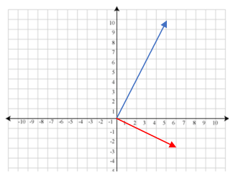

## THE UNIT VECTOR

A unit vector is a vector of length 1.

A unit vector is a vector of length 1. A unit vector in the same direction as the vector $\vec{v}$ is often denoted with a “hat” on it as in $\hat{v}$. We call this vector “v hat.”

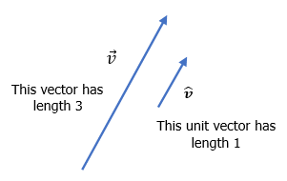

The unit vector $\hat{v}$ corresponding to the vector $\vec{v}$ is defined to be

$$\hat{v}=\frac{\vec{v}}{\left\|\vec{v}\right\|}$$

The unit vector corresponding to the vector $\vec{v}=\left\langle -8,\left.12\right\rangle \right.$ is

Example (3)

$$\hat{v}=\frac{\vec{v}}{\left\|\vec{v}\right\|}$$

$$\hat{v}=\frac{\left\langle -8,\left.12\right\rangle \right.}{\sqrt{{\left(-8\right)}^{2}+{\left(12\right)}^{2}}}$$

$$\hat{v}=\frac{\left\langle -8,\left.12\right\rangle \right.}{\sqrt{64+144}}$$

$$\hat{v}=\frac{\left\langle -8,\left.12\right\rangle \right.}{\sqrt{208}}$$

$$\hat{v}=\left\langle \frac{-8}{\sqrt{208}},\left.\frac{12}{\sqrt{208}}\right\rangle \right.$$

## USING TECHNOLOGY

We can use technology to find the angle $θ$ between two vectors.

Go to www.wolframalpha.com.

To show that the vectors $\vec{u}=\left.⟨2,-3\right\rangle$ and $\vec{v}=\left\langle -8,\left.12\right\rangle \right.$ are parallel**,** enter angle between the vectors <5, -3> and <2, 4> in the entry field. Wolframalpha tells you what it thinks you entered, then tells you its answer. In this case, $θ=180°$, indicating the two vectors are parallel.

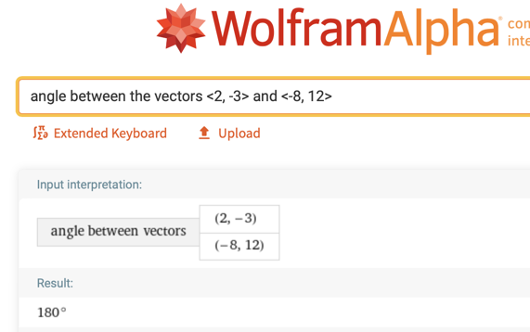

## EXAMPLES

1. Determine if the vectors $\vec{u}=\left.⟨2, 16\right\rangle$ and $\vec{v}=〈\frac{1}{2}, 4〉$ are parallel to each other, perpendicular to each other, or neither parallel nor perpendicular to each other.

ANS: Parallel

1. Determine if the vectors $\vec{u}=\left.⟨2, 1\right\rangle$ and $\vec{v}=\left.⟨3 ,-6\right\rangle$ are parallel to each other, perpendicular to each other, or neither parallel nor perpendicular to each other.

ANS: Perpendicular

1. Determine if the vectors $\vec{u}=\left.⟨7, 6\right\rangle$ and $\vec{v}=\left.⟨2, -1\right\rangle$ are parallel to each other, perpendicular to each other, or neither parallel nor perpendicular to each other.

ANS: Neither parallel nor perpendicular

4.Find the unit vector corresponding to the vector $\vec{v}=\left.⟨2, -1\right\rangle$.

ANS: $\hat{v}=\left\langle \frac{2}{\sqrt{5}},\left.\frac{-1}{\sqrt{5}}\right\rangle \right.$

## NOTE TO INSTRUCTOR

1. Show that $\vec{u}=\left.⟨1, 4\right\rangle$ and $\vec{v}=\left\langle 4,\left.16\right\rangle \right.$ are parallel to each other.

Method 1

$$θ= \cos^{-1}\frac{\vec{u}∙\vec{v}}{‖\vec{u} ‖∙‖\vec{v} ‖}$$

$$θ= \cos^{-1}\frac{\left.⟨1,4\right\rangle ∙\left\langle 4,\left.16\right\rangle \right.}{\sqrt{1^{2}+4^{2}}∙\sqrt{4^{2}+{16}^{2}}}$$

$$θ= \cos^{-1}\frac{1∙4+4∙16}{\sqrt{1+16}∙\sqrt{16+256}}$$

$$θ= \cos^{-1}\frac{68}{\sqrt{17}∙\sqrt{272}}$$

$$θ=0°$$

Make sure your calculator is in degree mode, not radian mode.

Method 2

Show that $\vec{u}=c\vec{v}$.Notice that $\vec{v}=4\vec{u}$.

$$\left\langle 4,\left.16\right\rangle =4\right.\left.⟨1,4\right\rangle$$

1. Show that the vectors $\vec{u}=\left\langle 2\right.$, $\left.1\right\rangle$ and $\vec{v}=⟨3,-6⟩$ are perpendicular to each other.

Method 1

$$θ= \cos^{-1}\frac{\vec{u}∙\vec{v}}{‖\vec{u} ‖∙‖\vec{v} ‖}$$

$θ= \cos^{-1}(\left\langle 2\right.$, $\left.1\right\rangle ∙\left\langle 3\right.,-6⟩)/(2^2+1^2)∙√(3^2+6^2 ))$

$$θ= \cos^{-1}\frac{2∙3+1∙(-6)}{\sqrt{4+1}∙\sqrt{9+36}}$$

$$θ= \cos^{-1}\frac{0}{\sqrt{5}∙\sqrt{45}}=0$$

$$θ=90°$$

The dot product of these two vectors is 0.

Method 2

1. Find the unit vector corresponding to the vector .

[2-5_parallel_and_perpindicular_vectors_and_projection.docx](https://oer4cte.org/math4gamedevelopers/teacher/2-5_parallel_and_perpindicular_vectors_and_projection.docx), attributed to Denny Burzynski (author) and Downey Unified School District (publisher) is licensed under CC BY-NC 4.0. To view a copy of this license, visit https://creativecommons.org/licenses/by-nc/4.0